

Islington Hackathon 2026 — Final Submission
Problem Statement 2 — Smarter Systems, Stronger Records
KramIQ · RTE Integrated Management System · Team: The Biggys
Live: kramiq.tech · Status: kramiq.tech/status · Code: github.com/Salokya-1/The-Biggys

Team Information

Team Name
The Biggys

Team Members
Name | Role / Contribution
Salokya Ghimire | Backend & API, frontend, database design, mobile app, DevOps and deployment
Sujal Shiwakoti | DevOps & integration, deployment support, testing
Samriddha Bahadur Basnet | UI/UX, quality assurance, documentation
Dristi Shakya | UI/UX, mobile app, quality assurance, documentation

About the Project

Project Name
KramIQ — RTE Integrated Management System

Project Overview
KramIQ replaces the spreadsheets the RTE department runs on with one system that keeps the record straight. Staff enter or import marks; the system validates them, computes grades, and routes each sheet through module-leader review and admin approval before anything is published, with an append-only audit trail behind every change. It also builds the weekly routine and the exam schedule against the college's own allocation rules, generates anti-cheat seating, tracks attendance, invoices fees and gates admit cards on payment. RTE staff, module leaders, lecturers and students each see only what their role allows. It runs as a web application with an Android companion app, built on Next.js, Fastify, PostgreSQL and Flutter, and is deployed and publicly reachable at kramiq.tech.

The Problem We Chose to Solve
Results, timetables, seating and fees are held in separate spreadsheets that are copied by hand between staff. Nothing validates a mark before it is published, nothing records who changed what, and a timetable clash or an over-subscribed exam hall is found by a person noticing it. We built the system that makes those mistakes hard to make and easy to find.

Features

Role-based sign in
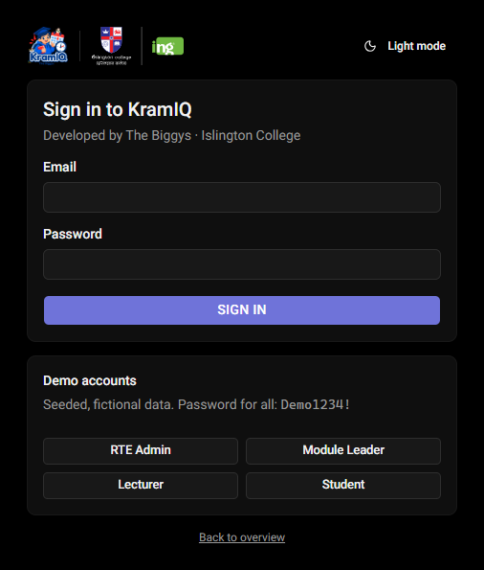
Sign-in page with the four demo roles.
Everyone signs in to the same system and sees a different one. Capabilities are held as a catalogue of thirty-eight named permissions rather than four hard-coded roles, so RTE can grant one lecturer the right to publish results without making them an administrator.

Operations dashboard
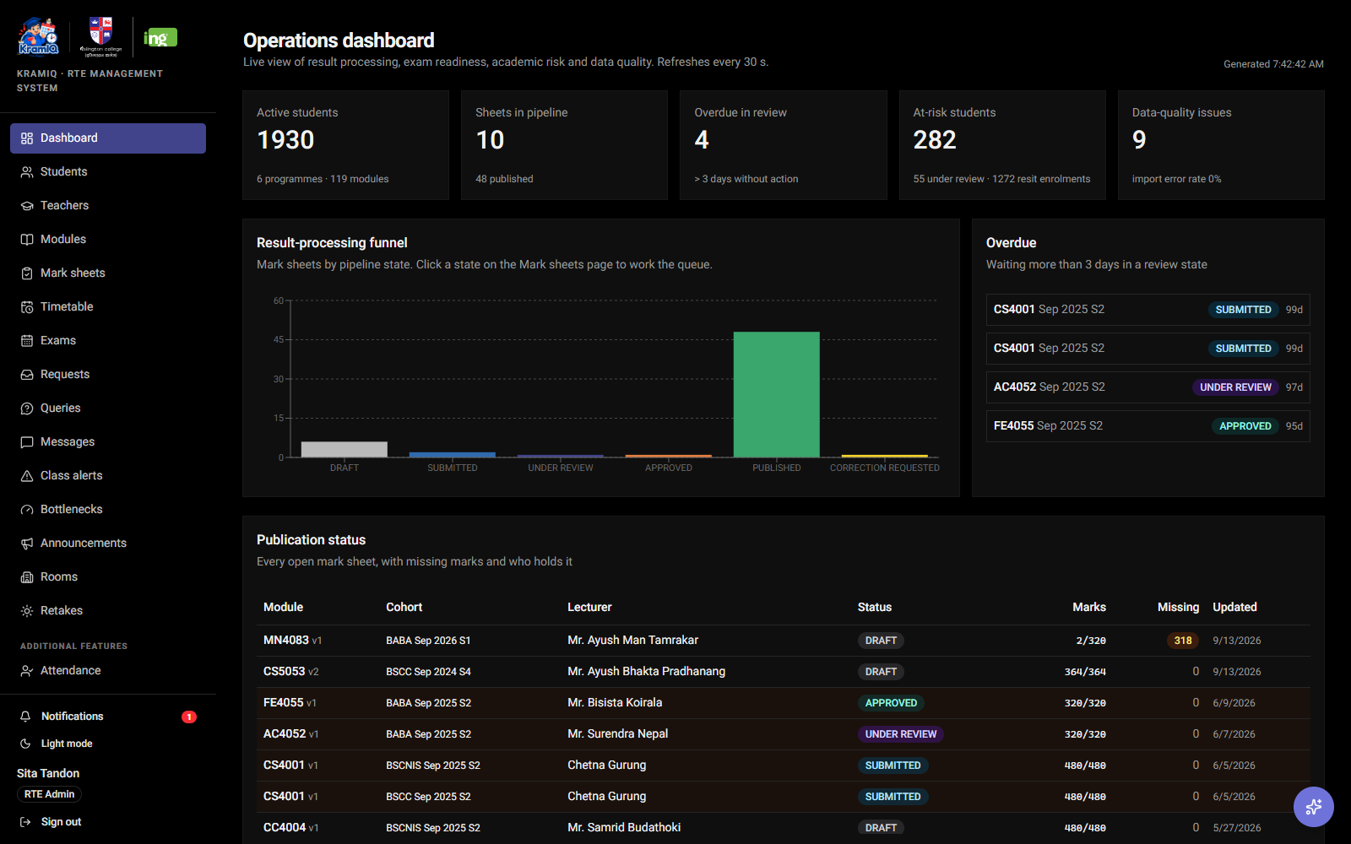
Live dashboard: active students, sheets in the pipeline, overdue reviews, at-risk students, data-quality issues.
The first screen an RTE administrator sees answers "what needs me today". It shows where every mark sheet is in the pipeline, what has been sitting too long, which exams are not yet seated, and which students are at academic risk — all computed live from the records rather than kept in a status column.

Where things are stuck
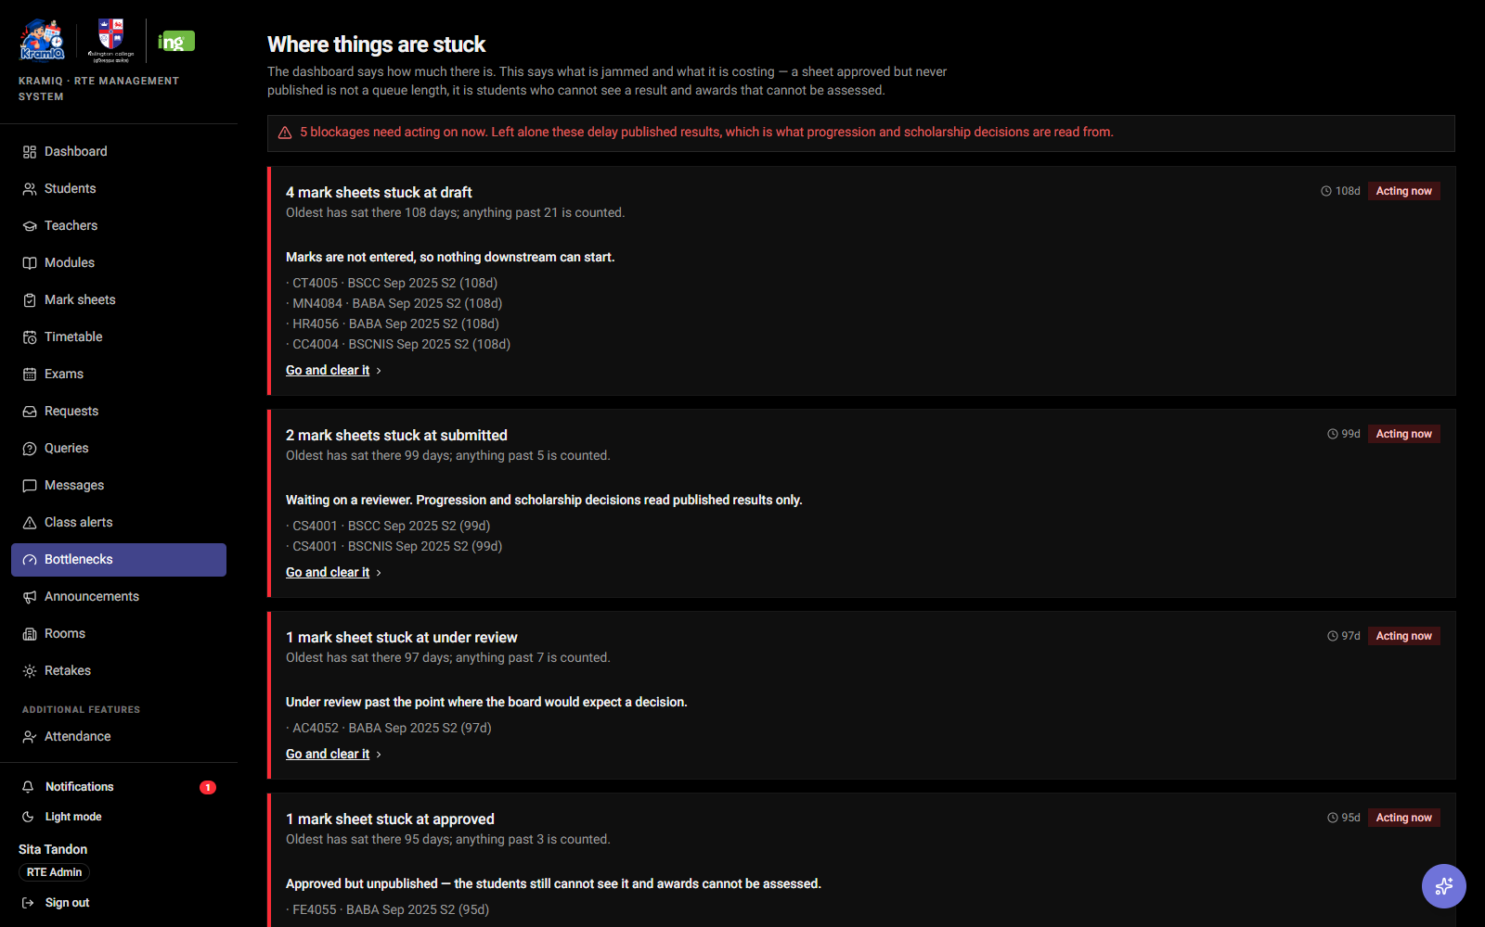
Bottlenecks: each blockage ranked by how long it has been stuck, with its consequence named.
A dashboard tells you how much there is; this tells you what is jammed and what it is costing. A sheet approved but never published is not a queue length — it is students who cannot see a result and scholarships that cannot be assessed. Each blockage is ranked by age and links straight to the screen that clears it.

Mark sheets, validated before publication
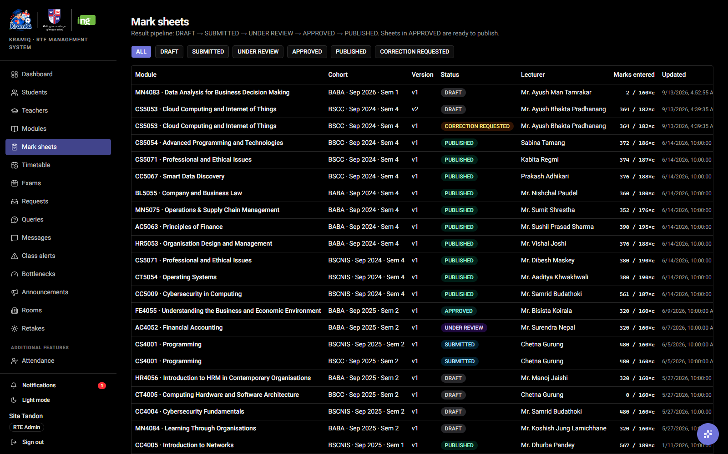
The mark-sheet queue with each sheet's state and version.
Marks are entered by hand or imported from a spreadsheet, checked row by row, and moved through draft → submitted → under review → approved → published. A mark above the component maximum is refused as it is typed. Statistical flags point out results far from a student's own history — explainable, never blocking, and never altering a mark.

Timetable built to the college's own rules
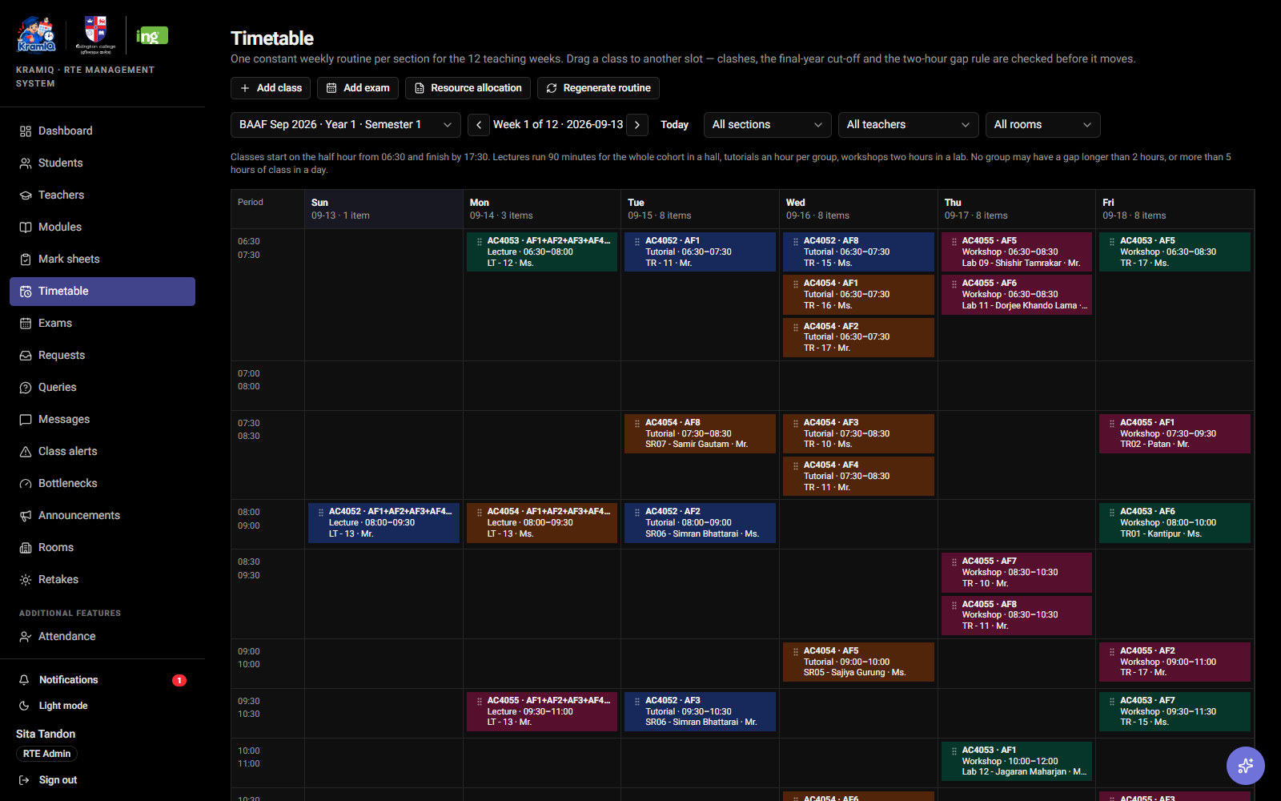
The weekly routine, drag-editable, with clash and constraint checking.
The generator models how Islington actually timetables: ninety-minute cohort lectures, hour tutorials, two-hour workshops, a Sunday-to-Friday week, per-year day patterns, and rooms typed as halls, labs, seminar or tutorial rooms. It holds gaps proportional to the classes either side and caps a group at five hours of teaching a day. A class can be dragged to a new slot; a move that breaks a rule is refused with alternatives.

Exams and anti-cheat seating
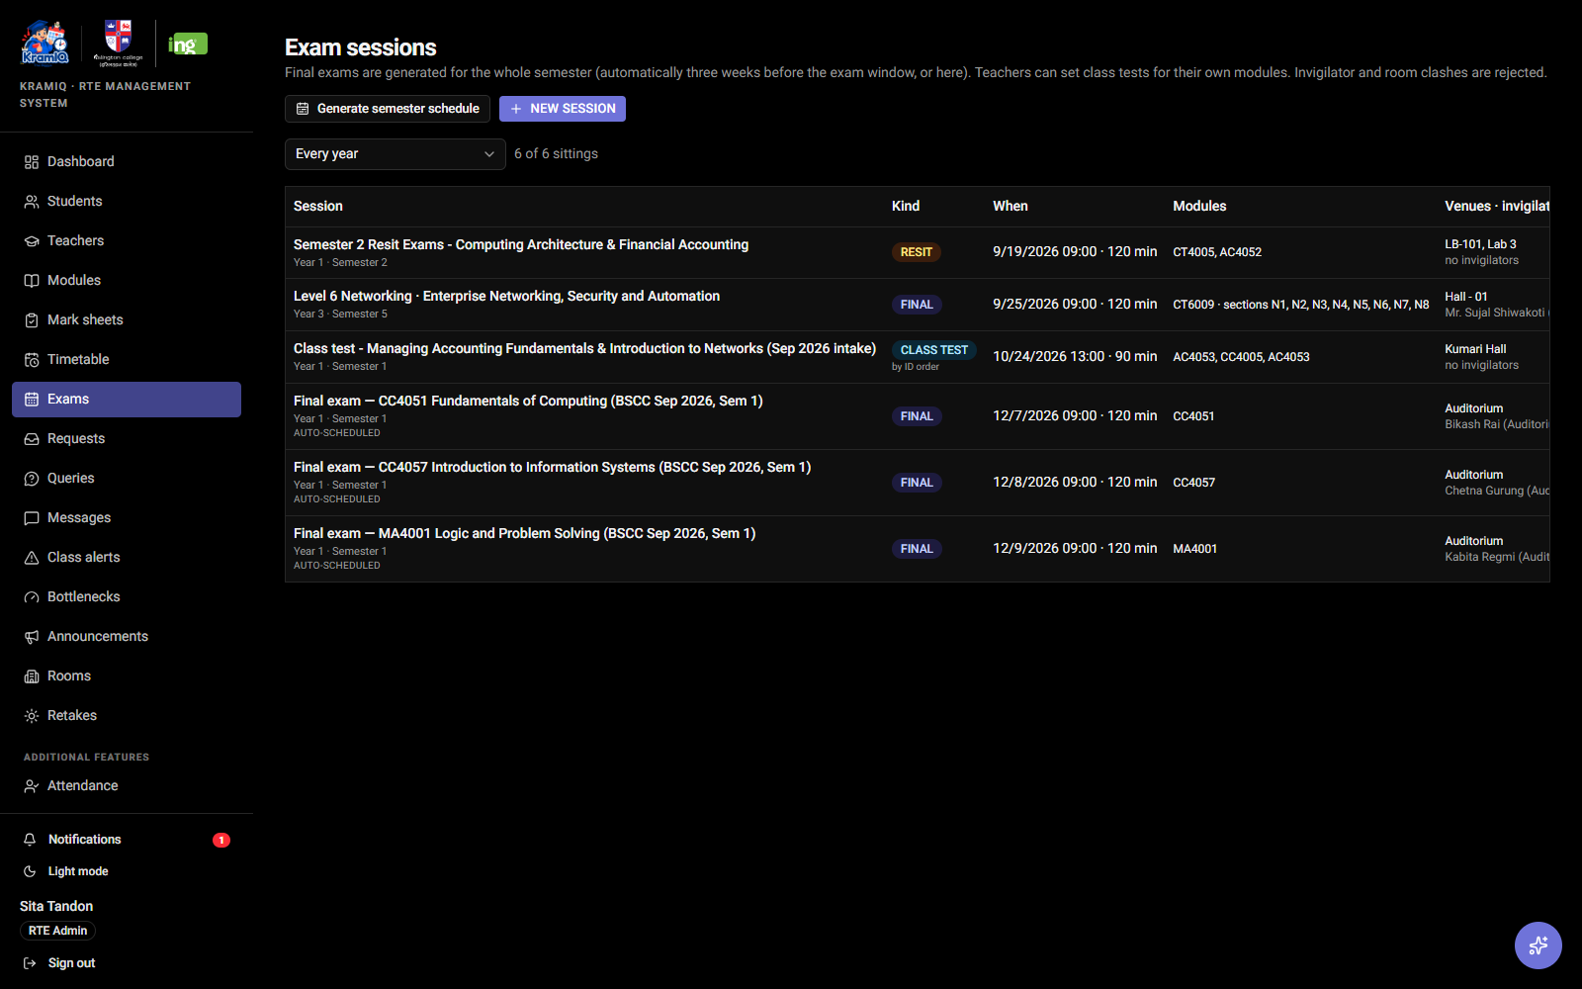
Exam sessions with candidates, capacity and seating state.
Whole-semester exam schedules are generated inside the two-week window, one sitting per cohort per day, with invigilators who do not teach the module. Seating is generated so no two students from the same module sit adjacent. An exam with more candidates than seats is flagged as a shortfall rather than reported as full.

Attendance and students at risk
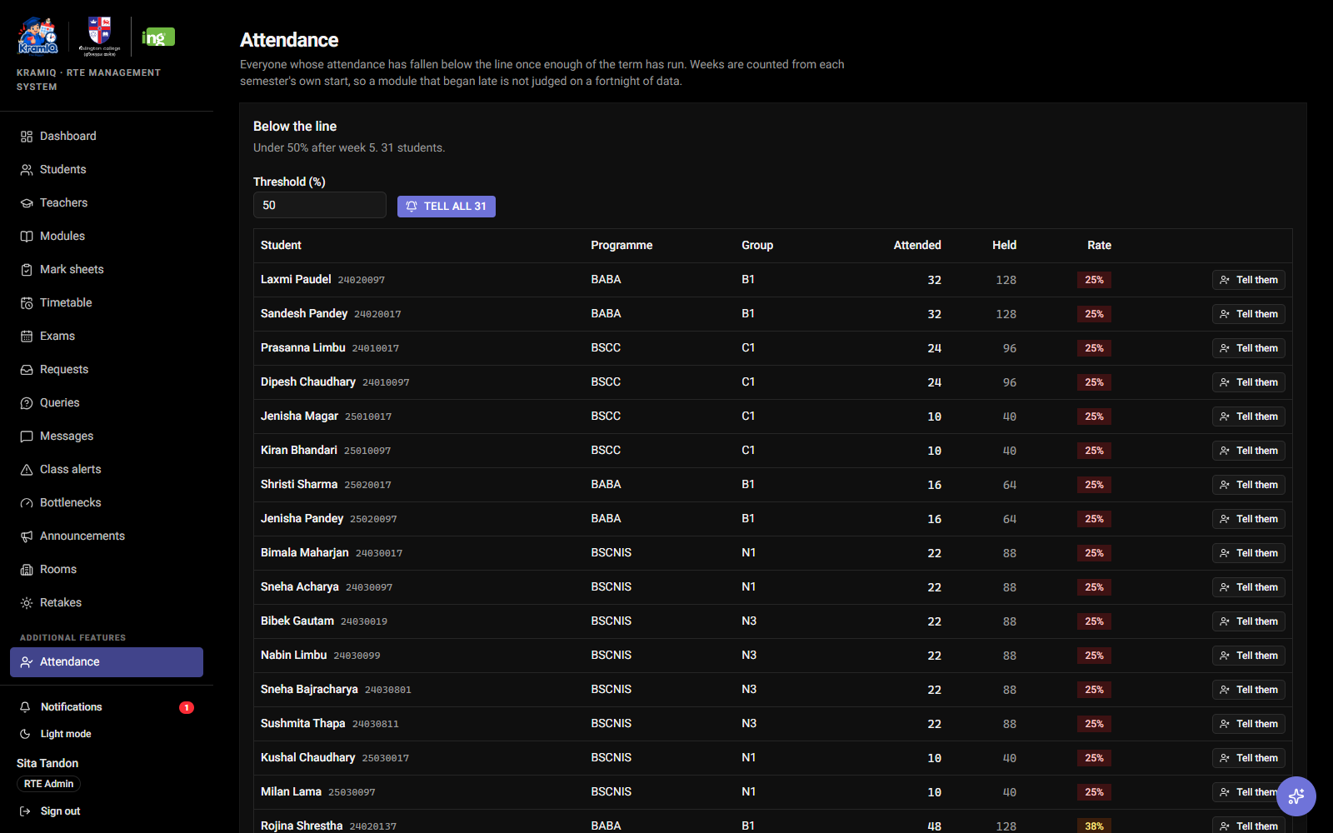
Everyone below the attendance threshold, with the rate they are actually running at.
Registers are taken from the class itself — everyone starts present and a tap changes it, so a room of twenty costs one tap. Once enough of a term has run, anyone below half their classes appears here and can be told in one action, long before the exam board finds out.

Every teacher, and the hours they cannot teach
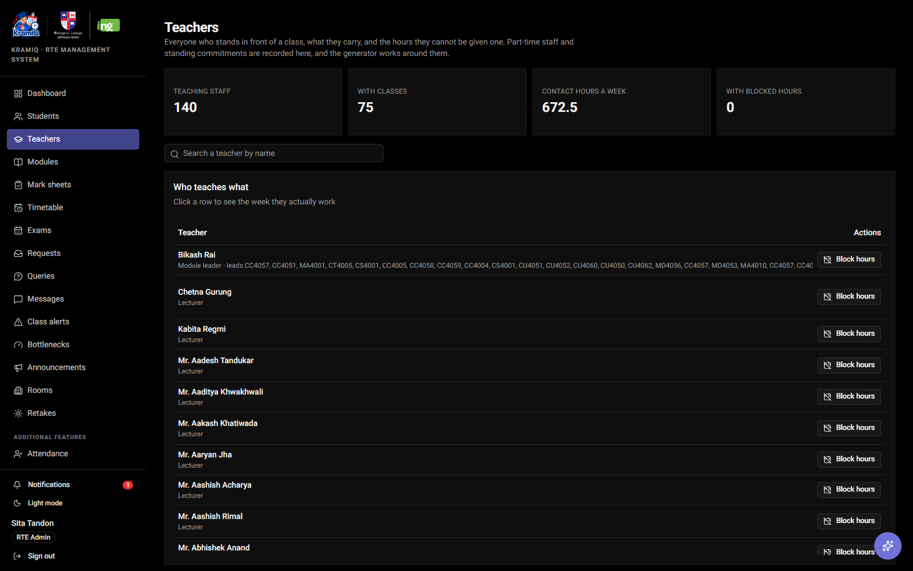
Teacher overview: modules, contact hours, classes and blocked windows.
Part-time staff, industry days and standing commitments are ordinary facts about a timetable, so teachers record them once and the generator works around them. Blocking an hour that already carries a class does not fail silently: it shows which classes would move and who could take them, and only proceeds when confirmed — then assigns cover and tells the students before they turn up.

Announcements to everyone at once
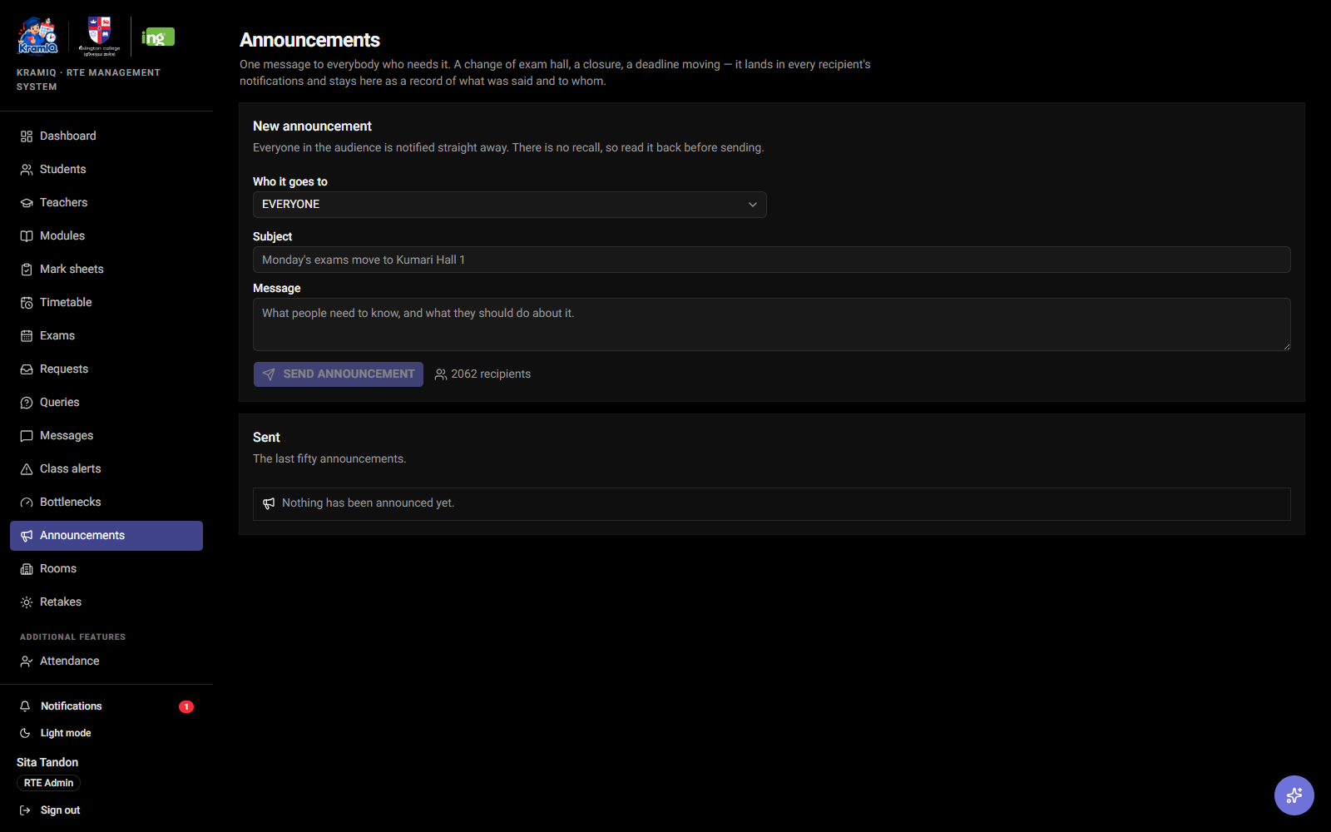
An announcement with its audience and recipient count, shown before sending.
One message to everybody, all students, all staff, or a single programme. The audience size is shown before sending because it cannot be recalled, and every announcement is kept as a record of what was said and to whom.

Import from the spreadsheets already in use
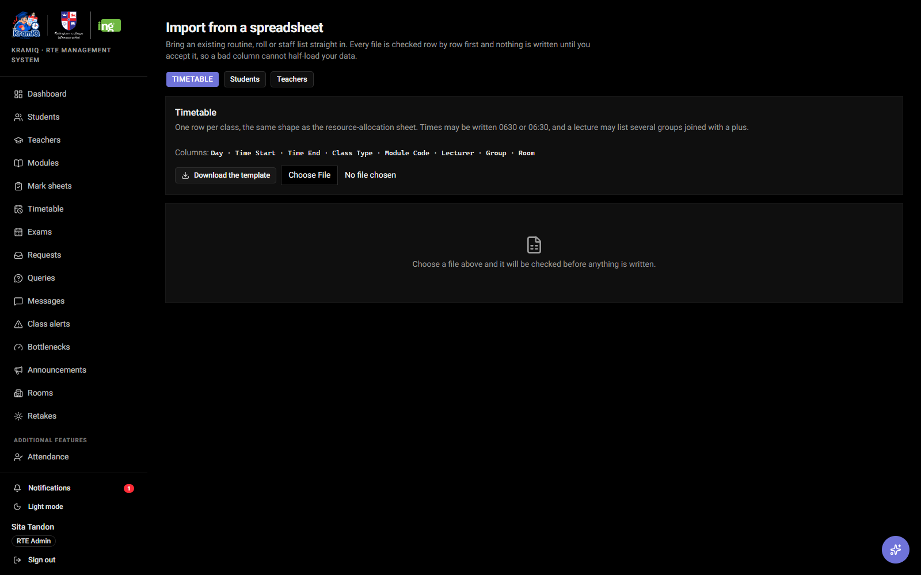
Import preview: every row validated before anything is written.
A department does not abandon its spreadsheets overnight. Timetables, student rolls and staff lists import from Excel or CSV with loose header matching, and every file is checked row by row first — nothing is written until the preview is accepted, so a bad column cannot half-load the data.

Rooms drawn as they really are
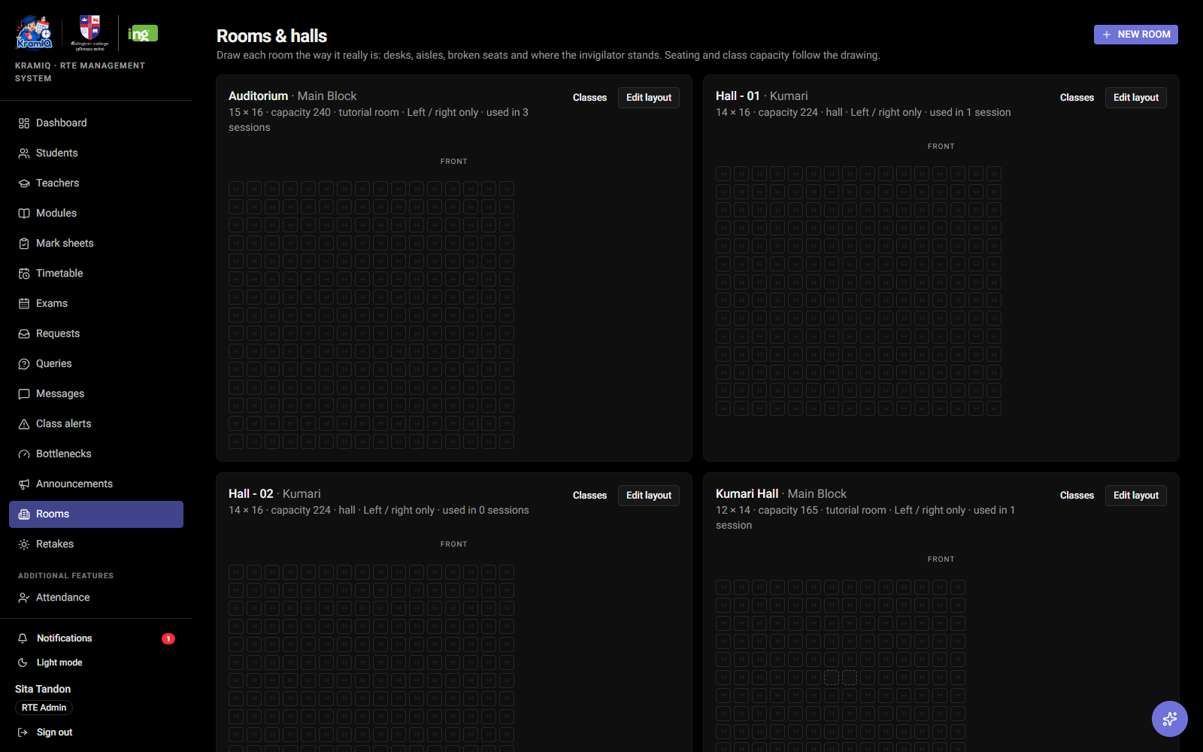
The room estate with seat layouts, types and buildings.
Rooms are drawn as grids with desks, aisles and unusable seats marked, so seating plans reflect the actual room rather than a seat count. Each room carries its building and type, which is what lets the timetable put a workshop in a lab and a cohort lecture in a hall.

The whole record behind one student
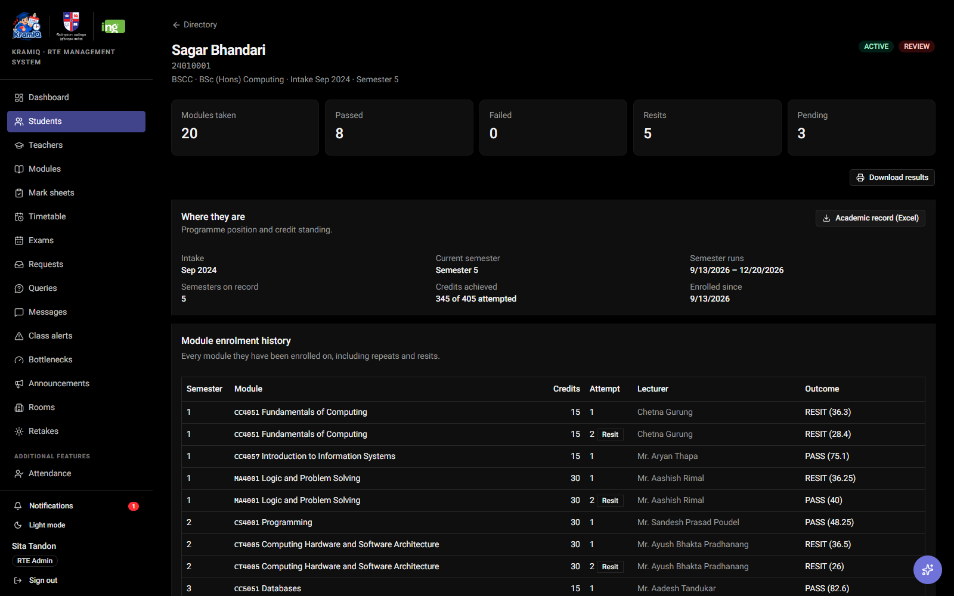
A student record: standing, credits, every module ever enrolled on, and downloads.
One page answers what the counter is actually asked: which semester they are in, what they have passed, what they are repeating, whether the fee is settled. Results print as an A4 statement with both crests, and the full record — details, results, component marks, attendance — downloads as a four-sheet workbook.

Android companion app
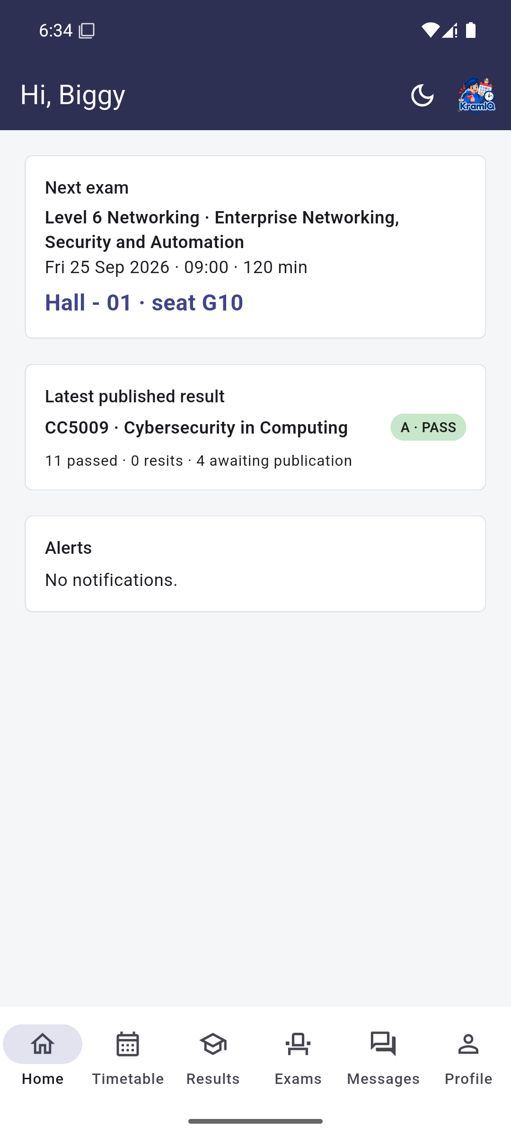 | 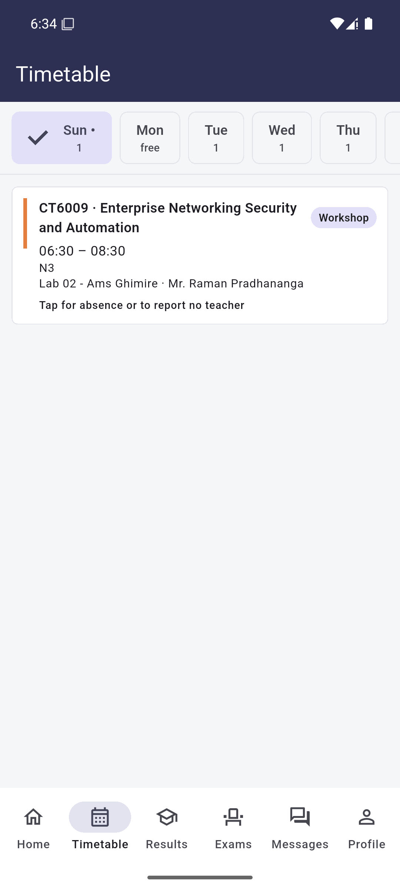
Student home with the next exam and seat, and the week's classes.
The same accounts, on a phone. Students see their timetable, results, exam seat and admit card, ask to be excused from a class, or report that no lecturer arrived. Staff take registers, record hours they cannot teach, and approve requests. It caches the last response so a weak signal shows the timetable rather than a spinner, and says plainly when what it is showing is offline. Installable APK, released on GitHub.

Public status page
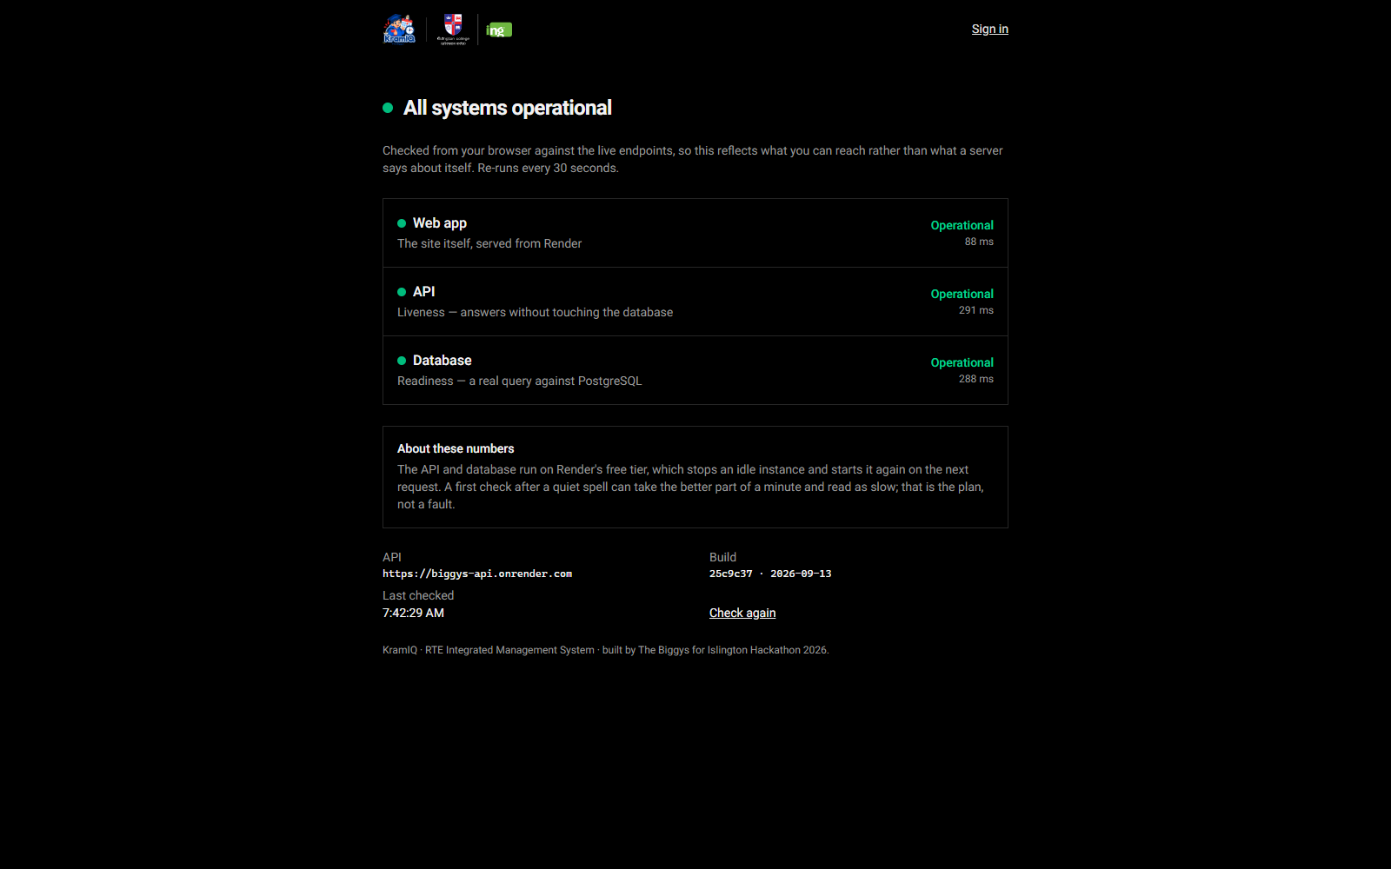
kramiq.tech/status — checked from the visitor's own browser.
Outside the app and behind no login, because the people who most need to know whether the system is up are the ones who cannot get into it. Each check runs in the visitor's browser against the live endpoints — the site, the API, and a real query through to PostgreSQL — so it reports what they can actually reach.

What does your project do, and why is it useful?
KramIQ takes the work the RTE department currently does across a dozen spreadsheets — results, timetables, exam seating, attendance, fees — and puts it in one system that checks itself. Marks cannot be published until every enrolled student has a mark, the weights sum to a hundred, and a module leader and an administrator have each signed off, and every change is recorded against the person who made it. Timetables and exam schedules are generated against the college's real constraints instead of assembled by hand, and clashes, over-subscribed halls and overloaded teaching days are refused rather than discovered. It is useful because the errors it prevents are the expensive ones: a wrong published mark, a student with no seat on exam day, a class nobody was told had moved. And because it is one record rather than twelve copies, the question "which spreadsheet is right?" stops being asked.

Key Differentiators

What Makes Your Project Different?
Unique Point | Short Explanation
1. Built to the college's real allocation model | Not a generic timetabler. Class kinds, durations, the Sunday–Friday week, per-year day patterns, room types and group codes come from Islington's own Autumn 2025 resource-allocation sheet, and the exporter reproduces its fourteen-column format. A published Level 6 Networking schedule was loaded over a real cohort as a test.
2. Approval-gated results with an audit trail | A mark sheet moves through review and approval before publication and cannot skip a state. Every mark, transition and correction is written to an append-only log with actor, timestamp and reason, so the answer to "who changed this and why" is in the system rather than in somebody's memory.
3. Constraints that refuse, with alternatives | Gap limits proportional to adjacent classes, a five-hour daily cap, final-year cut-offs, teacher and room clashes, seat shortfalls and impossible marks are all refused at the point of entry — and the refusal offers the slots or rooms that would work instead of just saying no.
4. It says what is stuck and what it costs | The bottleneck view turns queue lengths into consequences: an approved-but-unpublished sheet is reported as students who cannot see a result and awards that cannot be assessed, ranked by how long it has been sitting.
5. An assistant with the same permissions as the user | The in-app AI works through sixty-plus typed tools that call the same API the screens do, under the signed-in user's own permissions. It cannot do anything the person could not do themselves, and it says so when a request is refused.

Main User Roles
User | Main Responsibilities
RTE Administrator | Full operational control: students, timetables, exams and seating, fees and admit cards, announcements, camera-access requests, user accounts and per-user permissions, retake generation.
Module Leader | Reviews and approves mark sheets for their modules, sees the dashboard and bottlenecks, manages class alerts and support classes, answers queries.
Lecturer | Enters and submits marks, takes registers, views their own timetable and workload, records hours they cannot teach, reports absence and requests cover.
Student | Views timetable, published results, attendance, exam seat and admit card; requests to be excused; reports that no lecturer arrived; messages staff and raises queries.

Technical Implementation

Frontend
Next.js 16 (App Router) with React 19, TypeScript, Tailwind CSS 4 and shadcn/ui. TanStack Query handles server state and caching, recharts draws the analytics, and next-themes provides light and dark modes. Screens are permission-aware: the navigation and the actions on a page are built from the capabilities the signed-in account actually holds.

Backend
Fastify 5 on Node.js with TypeScript. Around thirty route modules cover results, timetabling, exams and seating, attendance, fees, messaging and administration. Every request body is validated with Zod, errors are returned in one shape, and permission checks run as route pre-handlers rather than inside handlers. Grading, seating and timetable generation are pure functions in a library, covered by 95 unit tests.

Database
PostgreSQL 17 via Prisma 6, with 36 models under version-controlled migrations. It holds programmes, intakes, semesters, sections and modules; enrolments, mark sheets, marks and results; timetable slots and one-day exceptions; exam sessions, venues, seat allocations and admit cards; attendance registers; fee invoices; announcements, messages, queries and notifications; and an append-only audit log of every change.

APIs / Integrations
OpenRouter powers the in-app assistant through a typed tool interface. ExcelJS produces the workbook exports and reads spreadsheet imports; PDFKit renders seating plans and admit cards. Email is written to an outbox first and delivered over SMTP when configured, so a mail failure never loses the request. Hosted on Render (web, API and PostgreSQL) with the domain on Namecheap DNS.

Authentication
Email and password with bcrypt hashing, short-lived JWT access tokens and rotating refresh tokens, with lockout after repeated failures. Authorisation is a catalogue of thirty-eight named capabilities: each role holds a default set, and an administrator can grant or revoke any single capability for one person without changing their role.

Project Limitations
- Notifications are in-app and polled, not pushed — there is no web-push or Firebase delivery to a closed phone.
- Email delivery needs an SMTP account to be configured; without one, messages queue in the outbox and are marked as such rather than sent.
- Integration with the college's existing systems is simulated: the data is realistic and imported in the college's own formats, but there is no live link to an SIS.
- The fee gateway is a mock — payments are recorded, not taken.
- Timetable generation is a good greedy placement with compaction, not a global optimiser; it satisfies the constraints but does not prove the result is optimal.
- Hosting is Render's free tier, so an idle instance sleeps and the first request after a quiet spell can take up to a minute.

Future Improvements
- Push notifications to the phone for seat allocation, published results and class changes.
- Timetable optimisation that minimises gaps and room changes across the whole cohort rather than class by class.
- A live link to the college SIS so enrolment and programme data flow in rather than being imported.
- iOS build of the companion app alongside the existing Android release.
- Deeper analytics: progression forecasting, module-level trend analysis across intakes, and scholarship eligibility reporting.
- AI-assisted scheduling that proposes a routine and explains the trade-offs it made.
- Two-factor authentication for administrator accounts.

